**DEVEOPS**

**INSTALLING AND SETTING UP JENKINS ON A LINUX MACHINE**

**STEP 1 : RUN THE BELOW COMMANDS ON THE TERMINAL OF UBUNTU MACHINE .**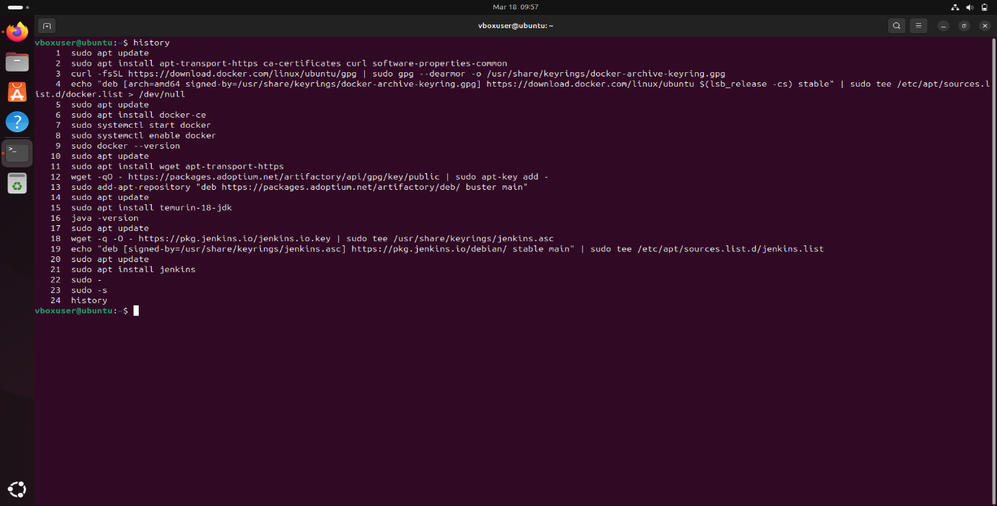

**STEP 2 : IP ADDRESS**

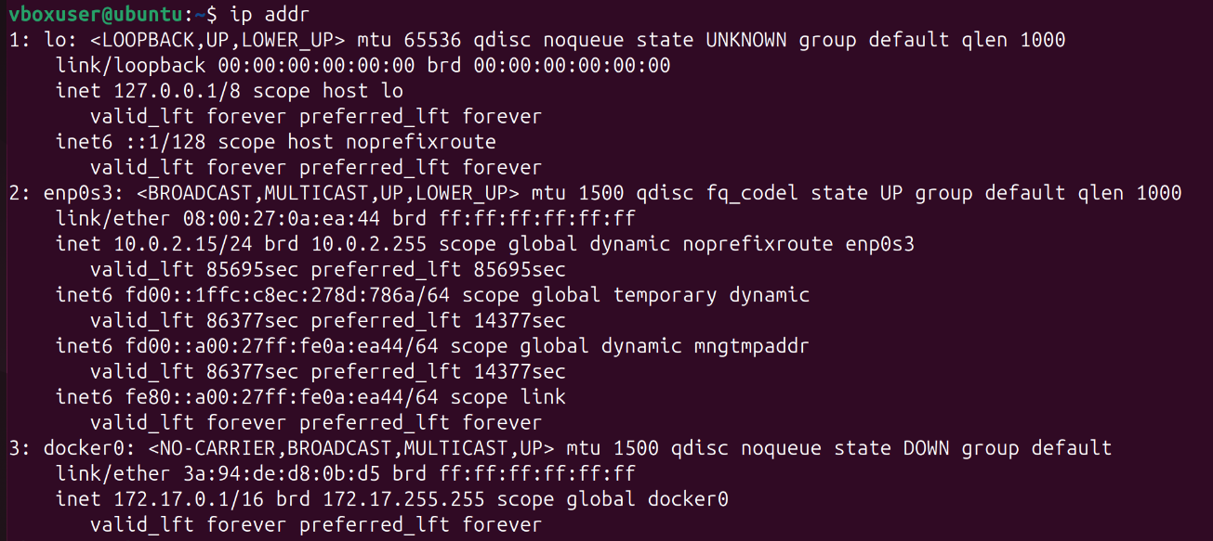

**STEP 3 : AFTER STEP 2, OPEN THE IP ADDRESS AS LIKE** [**http://10.0.2.15/8080**](http://10.0.2.15/8080) **AND LOGIN JENKINS ACCOUNT WITH YOUR USERNAME AND PASSWORD.**

**STEP 4 : AFTER STEP 3, CREATE A FREESTYLE PROJECT JOB BY CREATING AN ITEM NAME[EG : “SAMPLE”] AND SELECT FREESTYLE PROJECT AND CLICK OK.**

**STEP 5 : AFTER STEP 4, CONFIGURE A JOB TO INSTALL NGINX BY CLICKING “ADD BUILD STEP” AND SELECT EXECUTE SHELL TO RUN SHELL COMMANDS.**

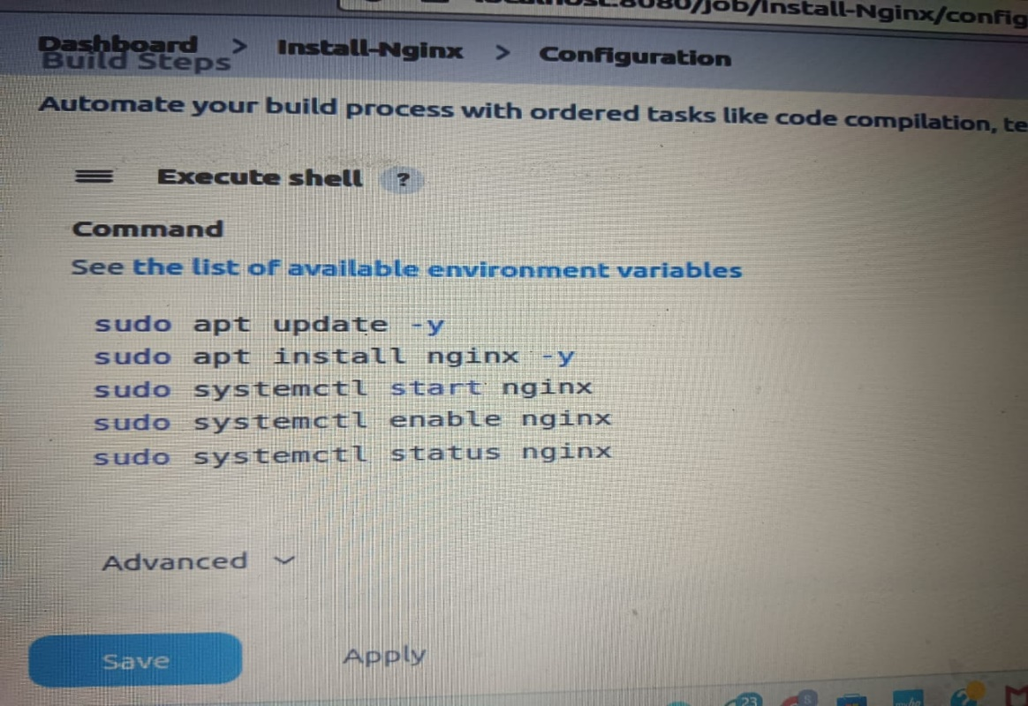

**STEP 6 : AFTER STEP 5, SAVE AND RUN JOB.**

**STEP 7 : AFTER STEP 6, CLICK “BUILD NOW” TO EXECUTE JOB.**

**STEP 8 : AFTER STEP 7, AS WE CAN CONSOLE OUTPUT.**

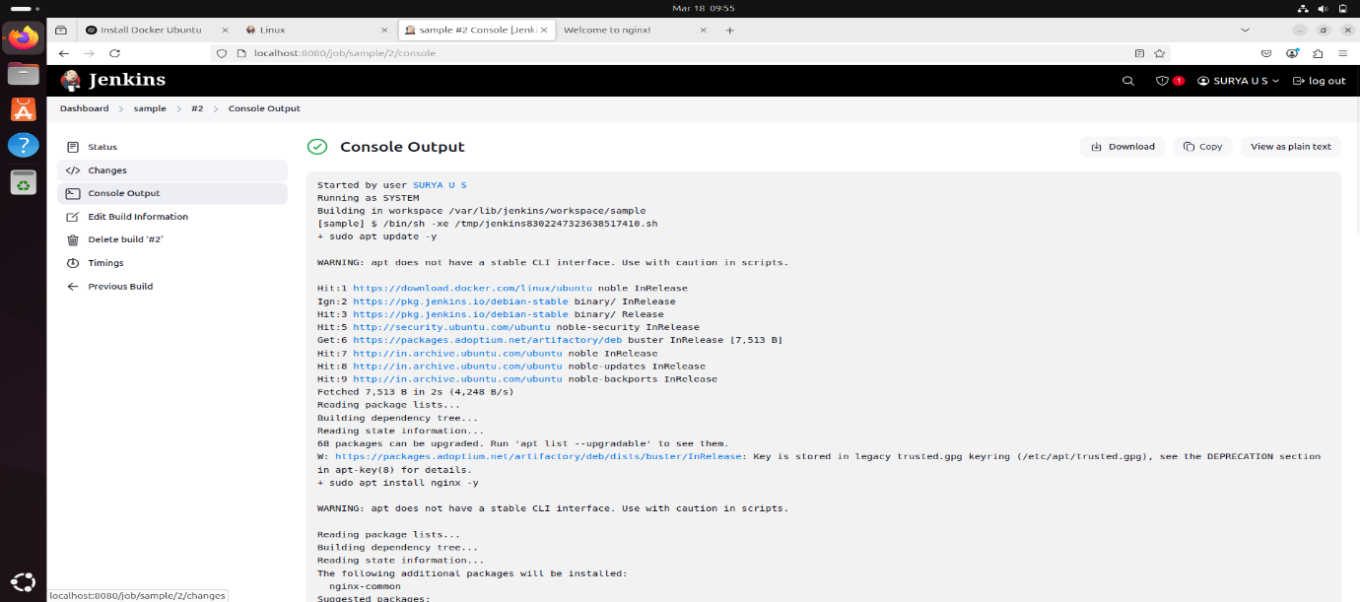

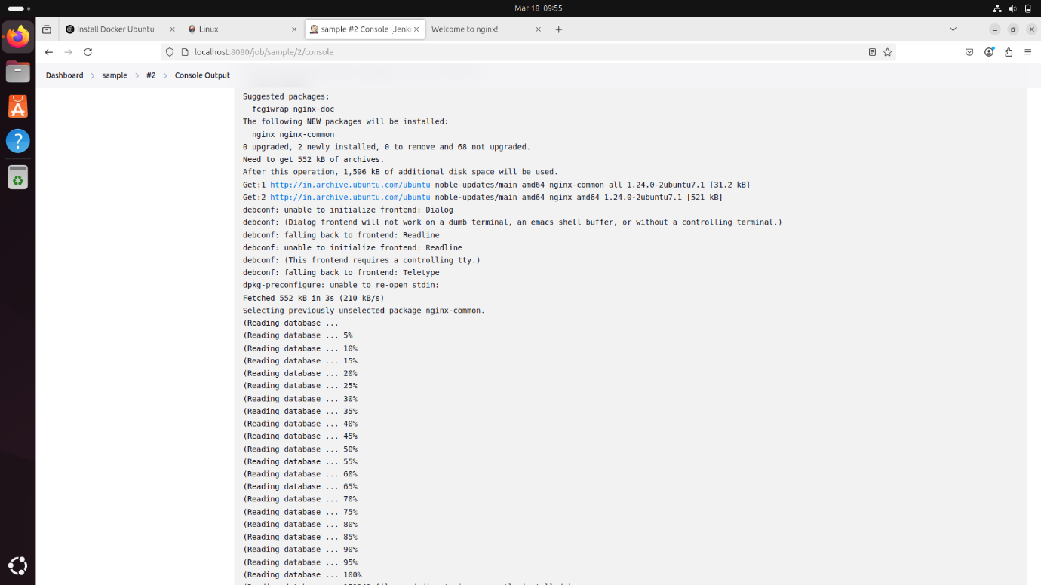

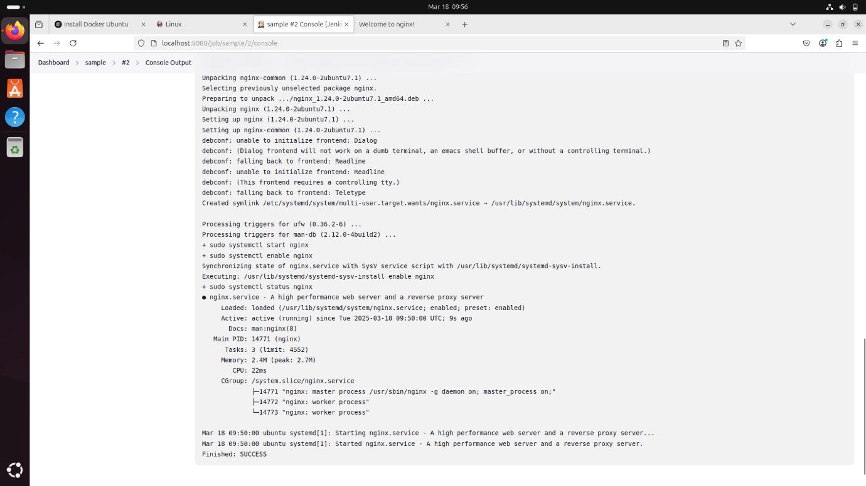

**STEP 9 : AFTER STEP 8, AS YOU CAN VERIFY NGINX INSTALLATION ON YOUR BROWSER.**